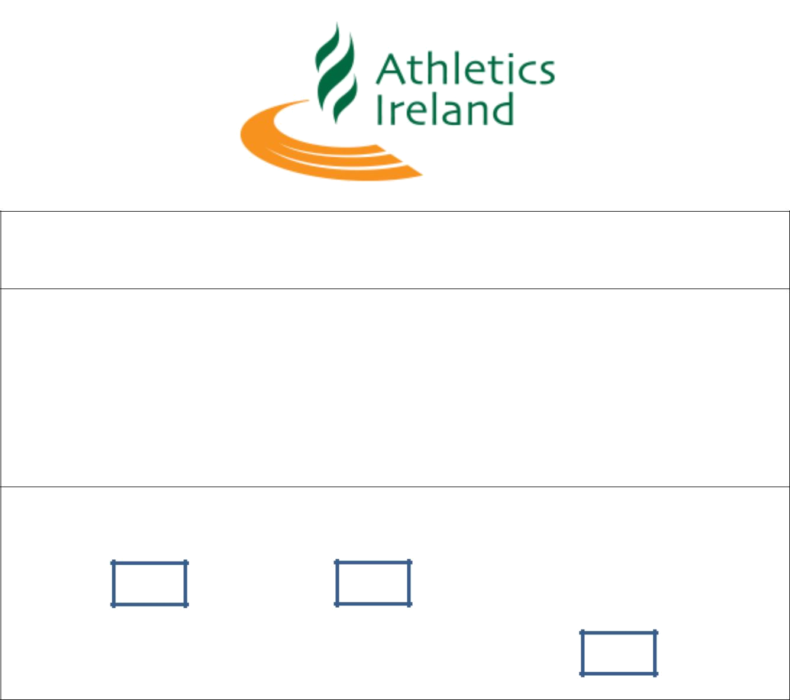

Team Declaration National 10k Championships 2018

Club :____________________________

Email: ____________________________

Phone: ____________________________

Category

Male Female

Senior |  | Master 35+ |  | Master 50+

First Name | Last Name | Date of Birth | AAI Life Reg No

Team Positions calculated on finishing times of each athlete

Please return completed form to competition@athleticsireland.ie closing date for Team Declaration Wed 11th April 2018 @2pm Sharp

There is no fee for Team Entries set by Athletics Ireland
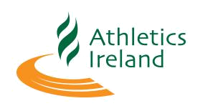

Athlete must wear club singlet alternatives permitted in certain circumstances with permission of meet manager / director on application with entry.

Athletes must be 18 years of age to compete in events of 10,000m and over.
In team events athletes may only score in the category for which they declare.

Team scores calculated on first 3 across line unless declared, finishing times, youngest age will apply to team category.

Championships medals will only be awarded to registered athletes

 | Score | Individuals | Club Teams
Senior Men | 4 | First 3 | First 3
Senior Women | 3 | First 3 | First 3
Masters Men | 3 | First 3 O/35 ,0/40…… | First 3- O/35 + O/50
Masters Women | 3 | First 3 O/35 ,0/40…… | First 3 - O /35 + O/50

