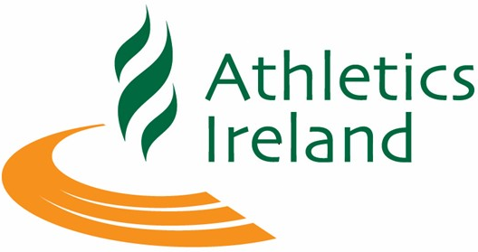
Athletics Ireland Board Bulletin
Northwood, AAI Office
Monday 21st October 2024
7.00pm-9.30 pm

In Attendance
John Cronin (JC), President, Chairperson
Brid Golden (BG), Deputy President, Munster Rep
Michael Quinlan (MQ), Chair Finance & Risk
Seamus Flynn (SF), Chair of Coaching and Development
Andrew Lynam (AL), Chair Competition
Marion McEvilly (MME), Connacht Rep
Greta Hickey (GH), Co-optee
Laura Brennan (LB), IUAA
Nuala Hunt (NH), Co-optee
Fintan Reilly (FR), Chair High Performance
Greg Duggan (GD), Leinster Rep
Amanda Hynes (AH), Chair of Juvenile

Attended Virtually
Claire Shannon (CS), Co-optee
Brendan McDaid (BMD), Ulster Rep

Apologies
David Abrahams (DA), ANI
Mary Barrett (MB), Schools ISAA

Also In Attendance
Hamish Adams (HA), CEO
Eimear Breathnach (EB), Paralympics Ireland, President - part
Stephen McNamara (SMcN), Paralympics Ireland, CEO - part
Kieron Stout (KS), AI – part.

- President – Welcome
John Cronin, President, welcomed everyone to the meeting and noted the apologies of DA & MB.

- Eimear Breathnach (EB) and Stephen McNamara (SMcN) were introduced to the meeting by HA who explained that discussions had been initiated between Paralympics Ireland and Athletics Ireland, with a view to a merger of the para athletics programme into HP. HA is to lead the integration review on behalf of Athletics Ireland.

- Kieron Stout (KS) joined the meeting to provide an update on HR and Safeguarding. KS provided statistics on courses provided and attendances at same.

- Conflicts of Interest - none advised.

- Minutes & Actions of September 9th, 2024, meeting were taken as read and proposed by GH and seconded by BG.

- Matters arising – none.
- Correspondence – none.

Matters for Discussion

- EGM Reflection.

- Strategic planning day 12th Oct 2024 reflections.

- Q3 Financials & Auditor update.

- Succession planning.

- Workplans.

Matters for Approval

- 2025 Budget draft submission.
- National Wage Agreement recommendation.
- Staff Handbook update.
- Risk Policy review & Risk Summary update.
- EGM Minutes.
- Constitution update post EGM.
- Insurance Broker tender.

CEO Report – taken as read.

AI Enterprises- update in CEO report, taken as read.

ANI & Provincial Reports – taken as read.

JC concluded the meeting.

2024 Meet Dates
2nd December

2025 Meet Dates.
20th Jan.; 17th Feb.; Tuesday 18th March.
Congress 2025, 26th April, Tullamore Court Hotel.

